A000-US-NE-Pine Ridge-Oglala Sioux-Gorget-early 19th c

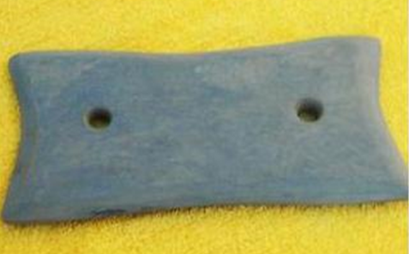

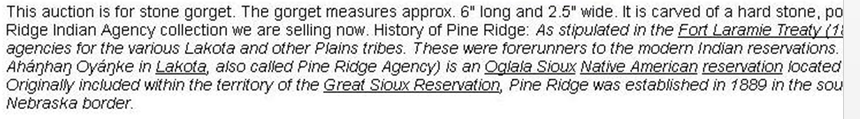

Oc t. 23 2011

Case no. 12